**PART A**

**EXPERIMENT NO. 3**

**A.1 Aim: -** To draw the behavioral view diagram: Sequence diagram, Collaboration diagram

**A.2 Prerequisite**

Determine the desired flow of action and their interaction with each other

**A.3 Outcome**

After successful completion of this experiment students will be able to -

1. Better understanding of the interaction diagrams.
2. Get familiar with sequence & collaboration diagrams.
3. Practice drawing the interaction diagrams using StarUML

**A.4 Theory**

Interaction diagrams describe how groups of objects collaborate in some behavior. An interaction diagram typically captures the behavior of a single use case. Interaction diagrams do not capture the complete behavior, only typical scenarios.

Diagram is used to describe some type of interactions among the different elements in the model. Interaction is part of the **dynamic behavior** of the system – snapshot of running system at a particular moment. Sequence diagram emphasizes on time sequence of messages collaboration diagram emphasizes on the structural organization of the objects that send and receive messages.

For sequence diagram things to be identified:

* Objects taking part in the interaction – three types of objects – Entity, Control, Boundary objects
* Message flow among objects
* The sequence in which messages are flowing
* Object organization

**Sequence Diagram -**

Sequence diagrams are a graphical way to illustrate a scenario:

* They are called sequence diagrams because they show the sequence of message passing between objects.
* Another big advantage of these diagrams is that they show when the objects are created and when they are destructed. They also show whether messages are synchronous or asynchronous

**Collaboration Diagram -**

They are the same as sequence diagrams but without a time axis:

* Their message arrows are numbered to show the sequence of message sending.
* They are less complex and less descriptive than sequence diagrams.
* These diagrams are very useful during design because you can figure out how objects communicate with each other.

**A.5 Procedure/Algorithm**

**A.5.1 Task:**

Draw a sequence diagram for the case study.

* Identify objects – entity, control, boundary objects
* Identify messages between objects.

**PART B**

|  |  |
| --- | --- |
| Roll No: B017 | Name: Niharika Dalal |
| Class: B. Tech. Comp. Engg. | Batch: B1 |
| Date of Experiment: 18.1.2016 | Date of Submission: 25.1.2016 |
| Grade: |  |

**B.1 Objects:**

**Entity objects:**

* Customer
* Dishes (database)
* Cart (database)
* Server

**Boundary objects:**

* Mobile phone screen
* Menu (to select action)

**Control objects:**

* Order
* Contact
* Share

**B.2 Sequence diagram:**

**……………………………………………………………………………………….**

# ORDER

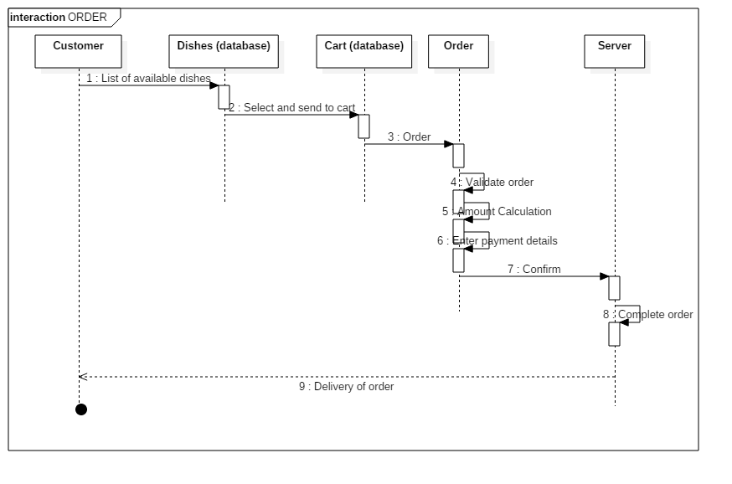

# SHARE

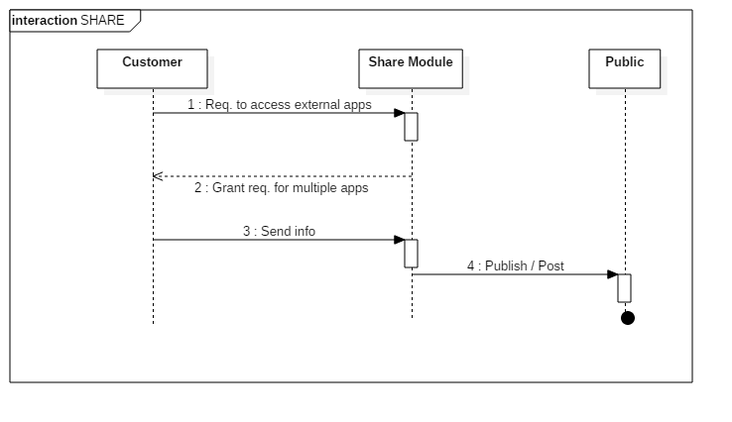

# CONTACT

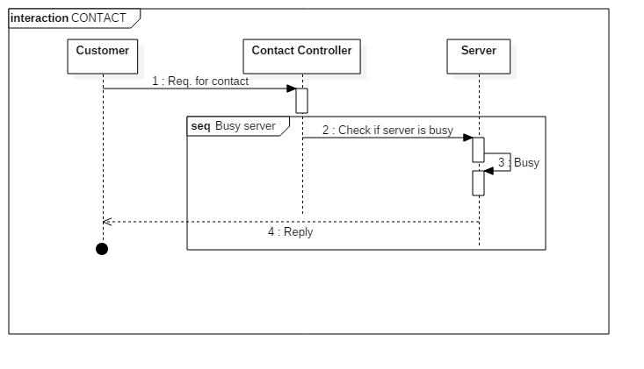

**……………………………………………………………………………………….**

**B.3 Collaboration diagram:**

**……………………………………………………………………………………….**

# CONTACT

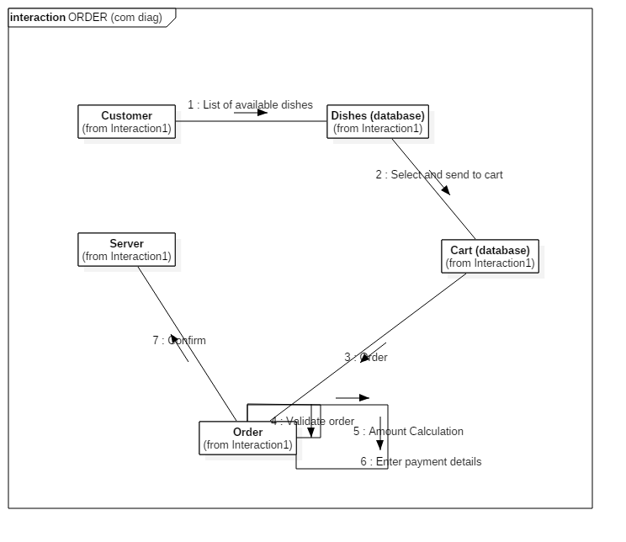

# SHARE

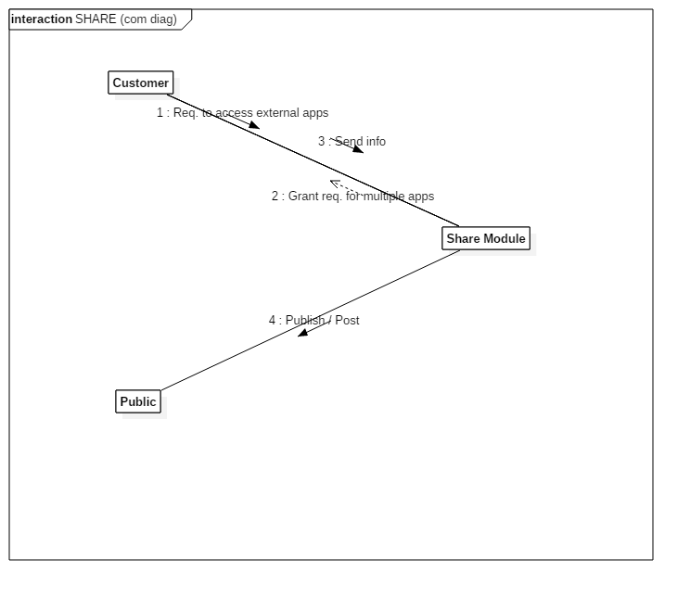

# CONTACT

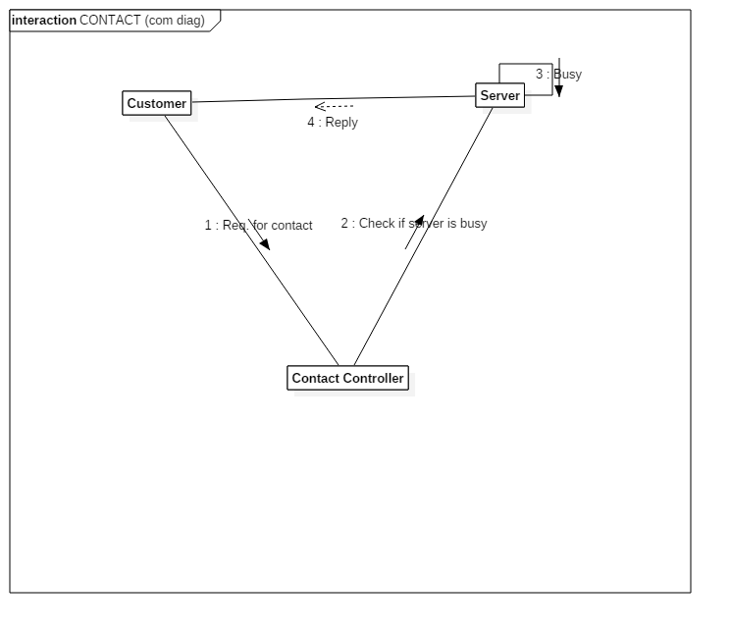

**……………………………………………………………………………………….**

**B.4 Conclusion**

………………………………………………………………………………………………………

A Sequence diagram is an [interaction diagram](https://en.wikipedia.org/wiki/Interaction_diagram) that shows how processes operate with one another and in what order. It depicts the objects and classes involved in the scenario and the sequence of messages exchanged between the objects needed to carry out the functionality of the scenario. A sequence diagram shows, as parallel vertical lines (lifelines), different processes or objects that live simultaneously, and, as horizontal arrows, the messages exchanged between them, in the order in which they occur.

A collaboration diagram resembles a [flowchart](http://whatis.techtarget.com/definition/flowchart) that portrays the roles, functionality and behavior of individual objects as well as the overall operation of the system in [real time](http://searchcio-midmarket.techtarget.com/definition/real-time). Collaboration diagrams are best suited to the portrayal of simple interactions among relatively small numbers of objects. In StarUML, a collaboration diagram can be obtained from a sequence diagram.

In this practical, we have created a sequence diagram and obtained the collaboration diagram from it.

………………………………………………………………………………………………………

**B.5 Questions of Curiosity:**

Q1. State the difference between entity, boundary and control objects.

………………………………………………………………………………………………………

**Entities**  
Objects representing system data, often from the domain model.

**Boundaries**  
Objects that interface with system actors (e.g. a user or external service). Windows, screens and menus are examples of boundaries that interface with users.

**Controls**  
Objects that mediate between boundaries and entities. These serve as the glue between boundary elements and entity elements, implementing the logic required to manage the various elements and their interactions.

………………………………………………………………………………………………………

Q.2 State the difference between sequence and collaboration diagram.

………………………………………………………………………………………………………

* Sequence diagrams show time-based object interaction while collaboration diagrams show how objects associate with each other.
* In sequence diagrams, we can show synchronous as well as asynchronous messages; in collaboration diagrams we can only show synchronous messages.

………………………………………………………………………………………………………

Q.3 When looping is required in sequence diagram?

………………………………………………………………………………………………………

Looping is required in sequence diagrams when you want some action to be repeated till a condition is met. This action involves the entity referring back to itself multiple times in order to complete a task.

………………………………………………………………………………………………………